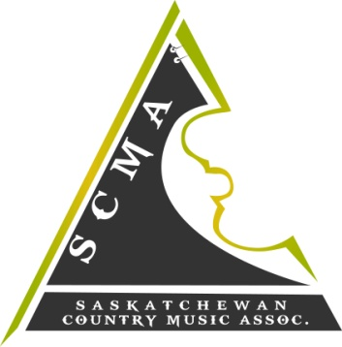
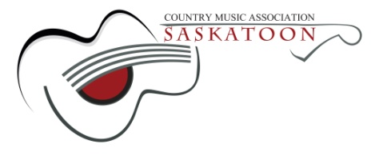

Hello S.C.M.A Members!
The 2017 S.C.M.A Host Committee would like to invite our members to apply for a performance spot at the 2017 "New Artist Showcase" during the Awards Weekend March 31st to April 2nd, in Saskatoon, Sk.
This is a fantastic opportunity for new, "up and coming" Saskatchewan artists to showcase their talent! This showcase will be held on April 1st, 2017 – 2pm at The Holiday Inn, (across from TCU Place) Saskatoon, SK.
Apply by completing and returning the attached application form along with the requested materials. The deadline for submissions is 12:00am (midnight) Friday February 17th, 2017 and the decisions will be made by March 4th, 2017.
Best of luck to all applicants!
Sincerely,
2017 S.C.M.A New Artist Showcase Committee

2017 S.C.M.A. AWARDS
March 31st, April 1st, April 2nd 2017
SHOWCASE APPLICATION
NEW ARTIST SHOWCASE

NAME_____________________________________________________________________
MAILING ADDRESS___________________________________________________________
CITY_________________ PROV. ____ P.C __________
PHONE # ______________ S.C.M.A MEMBERSHIP # ________________________
EMAIL : _____________________________________________________________
YOUTH (17 years or younger) ______________ ADULT (18 years or older) ____________

Have you showcased at the S.C.M.A's before? Yes ___________ No______________
If Yes, WHICH year? ___________________ ( you may NOT showcase 2 consecutive years )

-Please submit a promo-pack (picture/ MP3 of two songs / brief biography )
*preference will be given to those with original material

-ALL performers, including band members, must be members of the S.C.M.A.
*membership forms are available for download at www.scma.sk.ca

-ALL performers must have live accompaniment- NO taped music.

-We appreciate and thank all who apply, but submission of promo-pack does NOT
guarantee a spot. If you are not chosen, you may be put on a waiting list in the event
that someone cancels.

SUBMIT APPLICATION OR QUESTIONS VIA EMAIL: newartistshowcase2017@gmail.com
***DEADLINE FOR SUBMISSIONS IS 12:00am (midnight) on February 17th, 2017. APPLICANTS WILL BE NOTIFIED OF RESULTS BY MARCH 4th, 2017.
The NEW ARTIST SHOWCASE will be held Saturday April 1st, 2017 – 2pm at the Holiday Inn (across from TCU Place) in Saskatoon, Saskatchewan.

