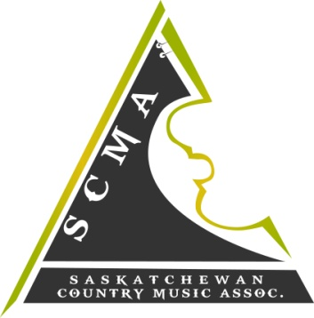

Hello S.C.M.A members!

The 2017 S.C.M.A Host Committee would like to invite our members to apply for a performance spot at the 2017 “Gospel Showcase” during the Awards weekend March 31st-April 2nd.
This is a fantastic opportunity for any of our gospel artists to showcase their talents or any new members that sing gospel to showcase their talents! A microphone and monitor will be provided by the S.C.M.A. Artists will be required to bring their own instrument and/or musician if necessary.
Applicants must be 18 years or older and sing gospel. This showcase will be held on April 2nd, 2017 at 11:30am-12:30pm.
Apply by completing and returning the attached application form along with the requested materials. The deadline for submissions is midnight CST Wednesday February 17th, 2017 and the notifications of results will be sent out by March 4th, 2017.

Best of Luck to all applicants!!

Sincerely,

2017 S.C.M.A Gospel Showcase Committee
2017 S.C.M.A. AWARDS
MARCH 31st – APRIL 2nd, 2017
SASKATOON, SK
Gospel Showcase Application

NAME_____________________________________________________________

BAND ________________________________________________________

ADDRESS_________________________________________________________

CITY ______________________ PROV. ____

POSTAL CODE _________________

PHONE #_______

S.C.M.A MEMBERSHIP #:____________________________

EMAIL____________________________________________________________

Qualifications/Deliverables:
♫ Have you performed the Gospel Showcase before? NO _____ YES____
IF YES, WHICH YEAR(s)? __________ (you may NOT showcase 2 consecutive years)
♫ Please submit the following:
- High-res picture
- 2 songs you’ve written in MP3 format (must be original material written by applicant)
- Brief biography (less than 100 words)
- Past 12 months accomplishments
♫ ALL performers including groups and individuals must all be members of the S.C.M.A.
♫ Membership forms are available for download on the S.C.M.A website (www.scma.sk.ca)
♫ We appreciate and thank all who apply. Submission of promo-pack does NOT guarantee a spot. If you are not chosen, you may be put on a wait list and contacted if a spot becomes available.
SUBMIT APPLICATION OR QUESTIONS VIA EMAIL: scmagospel.showcase@gmail.com
DEADLINE FOR SUBMISSIONS IS MIDNIGHT February 17th, 2017. APPLICANTS WILL BE NOTIFIED OF RESULTS BY MARCH 4th, 2017.

